Dealing with Animal-Related Injuries
Standard Operating Procedure
06/11/18 KM

For lacerations and puncture wounds where no potential biological hazard is present:
- Wash the affected area with mild soap and water for at least 5 minutes.
- Use direct pressure to stop bleeding if necessary.
- Apply antibacterial ointment and a clean bandage that will not stick to the wound.
- Inform your faculty supervisor, Department Safety Coordinator, College Safety Coordinator (801-422-6875), and/or Risk Management & Safety (801-422-4468) of the incident.
  - If stitches or additional treatment is necessary, clean the wound, washing or flushing the contaminated area thoroughly.
  - Proceed to Urgent Care at the BYU Student Health Center (1750 N Wymount Terrace Drive, Provo, UT 84604) for evaluation and follow-up. Student Health Center Urgent Care is open from 8:00 a.m. to 5:30 p.m. Monday through Friday.
    - If the incident occurs after-hours or on the weekend, go directly to the Emergency Department at Utah Valley Hospital (formerly Utah Valley Regional Medical Center) at 1134 N 500 W, Provo, Utah for evaluation and post-exposure follow-up.
Reporting a Bite in FileMaker Pro:
- In the 'Daily Animal Care' program in Filemaker Pro, click the bite log field and complete the required information.
- 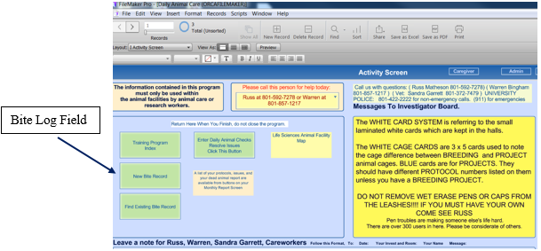
- If the bite causes a serious injury requiring medical attention, the supervisors will complete a Workers Compensation Injury Report. Find form on the Risk Management and Safety Website: https://risk.byu.edu/ or in the Standard Operating Procedure binder.

