CLONING PROTOCOL
Grose Lab
Written by KJ, last edited by JHG: 06/01/09

INTRODUCTION:
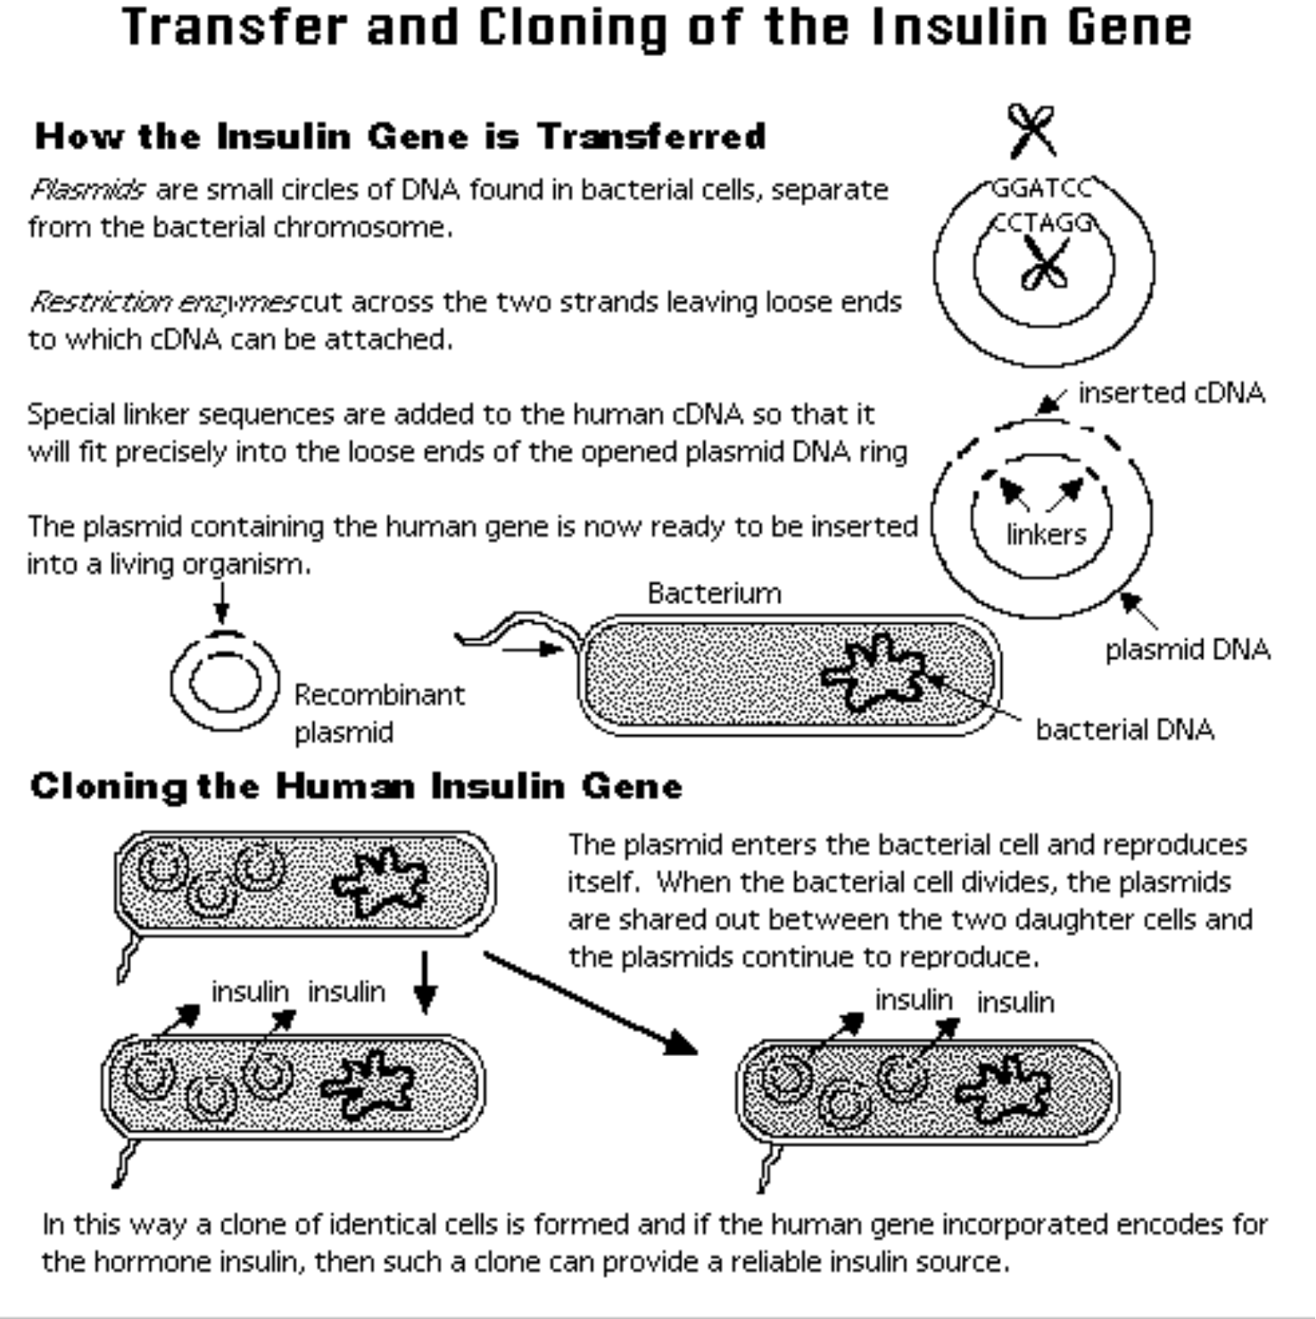
Cloning: a laboratory technique whereby a gene is isolated from its native DNA environment and inserted into a specialized DNA fragment (cloning vector), often a plasmid or bacteriophage. This allows the gene to grow in a foreign host, usually bacteria or yeast. Cloning allows the isolation of the gene from its natural environment for purposes of research. Cloning also allows the production of the gene in large amounts, both for research and in the production of commercially and clinically important gene products. An example is the production of human insulin in the bacteria E. coli used in the treatment of diabetes. Traditionally, the DNA fragment containing the gene has been isolated using restriction endonuclease enzymes. These cut the DNA at specific sites, allowing a particular fragment to be reproducibly isolated. This fragment is then inserted into a cloning vector, similarly digested with restriction endonucleases, by ligating the ends together. The composite DNA molecule is inserted (transformed) into a host in which it can multiply as an extrachromasomal element. Increasingly more common is the isolation of DNA fragments by PCR, by which a defined segment of DNA is located and amplified in vitro by a special DNA polymerase. This segment may then also be digested and inserted into a cloning vector.

STEP 1: Amplification and purification of insert (see “PCR Protocol” below).
- Design primers that will allow amplification of the gene of interest and that will incorporate appropriate restriction sites at the ends of the amplified molecules.
- Run a 50-µl PCR amplification of your insert and assess the quality of the product by loading a small amount on an analytical agarose gel. A solid ethidium-stained band should be visible from 2 or 3 µl of PCR sample.
- PCR clean-up. It is necessary to purify the remaining PCR product from PCR buffer, unincorporated dNTP’s, polymerase and template. Use the Sigma PCR purification kit and follow the procedure in the Sigma manual (this is a quick ~10 minute procedure). ***If PCR product is ~150 bp or less then purify by adding 1 mL of cold ETOH , incubating at 4’C for 30 minutes, then pelleting in a centrifuge at top speed for 5 minutes. Remove ETOH, dry 5 min and resuspend in buffer.
- Re-check the cleaned up PCR product on an analytical agarose gel.

STEP 2: Vector preparation. The plasmid to be modified (“vector”) should be prepared by alkaline lysis purification from E. coli. Kits for small- and large-scale plasmid purification are typically used to generate 50-200 µl of purified plasmid DNA at a concentration that allows easy detection after loading 2 µl on an analytical agarose gel.

STEP 3: Restriction digest of insert and vector. There will be two separate reactions. One will be with the Purified PCR product and the other will be the vector that the gene will be inserted into.
- PCR product (insert) digestion (50 uL reaction)
~14 µl H₂O
5 µl 10X NEB buffer
0.5 µl 100X BSA
30 µl DNA sample
1-2 µl of each restriction enzyme
(**always mix reagents well before adding enzyme as the final reagent)

- Vector digestion (50 uL reaction)
~14 µl H₂O
5 µl 10X NEB buffer
0.5 µl 100X BSA
30 µl DNA sample
1-2 µl of each restriction enzyme
(**always mix reagents well before adding enzyme as the final reagent)

After all of these are mixed together they must be placed in the 37ºC bath or incubator for at least 1.5 hours (they may be left overnight).

Note: If a non-directional ligation will be performed (single restriction site), then you must dephosphorylate the vector by adding 0.5 µl of calf intestinal phosphatase (CIP) to the restriction digest for the last hour prior to low-melt gel purification (below).

STEP 4: Low-melt gel for purification of sticky-ended insert/vector. Low-melt agarose gel electrophoresis is similar to regular gel, with some exceptions: The low-melt agarose dissolves faster, and boils over more easily during microwaving, so microwave in brief pulses. Add the normal amount of ethidium bromide (~160 ng/ml) to the molten agarose before casting. Cast your gel in the fridge to accelerate solidification. Use a large-tooth comb to form wells that will accommodate ~40-50 µl of material. If you normally use TBE buffer for analytical gels, you need to convert to TAE, since the low-melt gel slices you use for subsequent ligation should be in TAE (the borate in TBE presumably inhibits DNA ligase). When running the gel, run at 90 volts (or else it may melt). It will take about 45-60 min to run.

When the gel has run, use a portable hand-held UV lamp (long wavelength UV to avoid DNA damage) and carefully remove the DNA bands from the gel with a razor blade. Place the DNA samples in clearly labeled microfuge tubes. Also cut out a slice of gel that has no DNA, for use as a no-insert control sample (see Ligation section below)

STEP 5: Ligation. Compatible sticky ends will bring vector and insert together only very transiently. DNA ligase forms phosphodiester bonds between vector and insert, making the construct stable. You will need to set up two reactions: vector+insert, and the vector-only control. The gel slices acquired above should be pre-heated to 65°C to get them melted. Once melted, these samples will remain liquid at room temperature for a few minutes.

Standard ligation reaction (15 µl):
6.5 µl H₂O
1.5 µl 10X ligase buffer (includes ATP)
1 µl T4 DNA ligase
3 µl vector
3 µl insert (or no-insert control sample)
(The first three components of this recipe may be combined as a master mix. Incubate these reactions at room temp. for at least 30 min.)

STEP 6: Transformation.
- Typically, E. coli strain DH5α is made chemically competent (see protocol for competent cells below). Thaw DH5α chemically competent cells on ice. Meanwhile, melt the ligations for a few mintues at 65°C. Also, be sure you have 42°C heat block ready as well as LB-agar plates with the proper antibiotic.
- When the DH5α is thawed, quickly add 2 ul of the ligation mix to ~25 ul of competent cells. Flick or vortex the tubes briefly and put them back in the ice for 5-10 minutes (it is important that the DH5α be kept as cold as possible during this process).
- Heat shock at 42°C for 60 seconds. Immediately place the tubes back on ice for 2-5 minutes.
- Add .5 ml of plain LB to the reactions and incubate at 37°C for 30-60 minutes (30 minutes if the selection is ampicillin, 60 minutes if the selection is anything else).
- Plate 100 ul of cells and incubate at 37°C over night.
Verifying Clones
Grose/Griffitts Labs

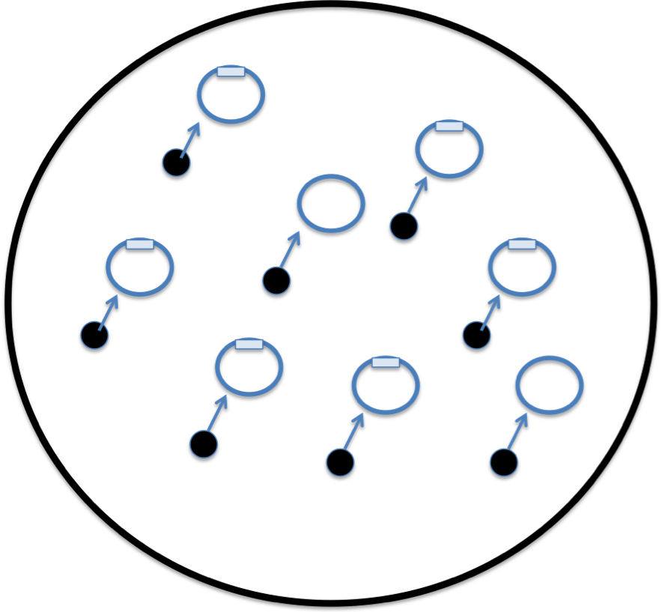
Once you have transformed E. coli with your ligation mix and plated, some colonies will contain a plasmid harboring your insert, while others will be plasmid only self-ligations. You can get an idea of your cloning efficiency by comparing the vector+insert tranformation efficiency with vector-only control.

There are two basic ways to check for inserts. First, you can perform colony PCR to check for inserts using primers specific for your plasmid. Second, you can purify plasmid and perform restriction digest. The former is much quicker and supplies you with a product that can be used to sequence from. Fortunately, E. coli cells boiled briefly in water make excellent template for PCR amplification with Taq polymerase.

Colony PCR:
Set-up a standard 25 uL Taq reaction mix using bacterial colonies as the template and primers that are specific to the plasmid and will amplify the insert (see figure below). To liberate bacterial DNA, the colonies will be boiled prior to addition. I generally check 4-8 colonies based on my expected cloning efficiency. 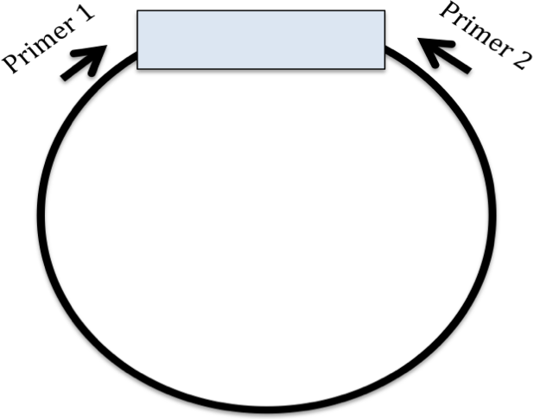

- Add 1 colony to 50 uL of water in a PCR tube. Do this by using a pipet tip (NOT A TOOTHPICK) and by carefully picking an ISOLATED colony. Be sure to streak to a plate after adding the colony to the water so that you can go back to the correct clone once it is identifid by PCR! Label the tube and the streak on the plate identically (for example geneX-A for colony A). Boil for 5 minutes in the PCR machine. The DNA is now ready to use as a template.

- Set up the following Taq PCR reactions. It is best to make a master mix and then aliquot to all tubes before adding template.

19 ul of water
2.5 ul Standard 10X reaction Buffer
0.5 ul 10 mM dNTP’s
0.5 ul each primer
0.5 ul Taq DNA polymerase (*add last to master mix)
then add 2 ul of boiled colony sample

After running PCR (25 cycles should be sufficient), verify inserts by running 5 ul of product on agarose gel. For 2 or 3 clones that test positive for insert, clean up the PCR and sequence.

PCR PROTOCOL
Grose Lab

STEP 1: Amplification of your gene of interest via PCR
There are two types of PCR polymerases used in the lab, Taq and high fidelity polymerases (such as Phusion or Pfx50). Taq has an error rate of about 1 bp change per 1 kb while many high fidelty polymerases have an error rate that is 60 times lower (see www.finnzymes.com/pcr/fidelity_calc.php ). The PCR protocols for different polymerases are very similar with the variable units being the buffers and PCR programs (denaturation and annealing temperatures as well as elongation times). Be sure to use Phusion according to the manufacturers guidelines (see the sample program below).Taq is cheaper than most high fidelity polymerases and will almost always give an abundance of product, therefore is used when accuracy is not an issue.

Phusion (50 ul reaction)
~35 ul ddH20
10 ul 5X Phusion buffer
1.5 ul 10 mM dNTP’s
1 ul each Primer (50 uM stock)
1 ul appropriate diluted template DNA
0.5 ul Phusion Polymerase

Taq polymerase (50 ul reaction)
40 ul ddH20
5 ul 10X TAQ buffer
1.5 ul 10 mM dNTP’s
1 ul each Primer (50 uM stock)
1 ul appropriate diluted template DNA
0.5 ul Taq Polymerase

Set up reactions on ice, and keep them on ice until placing them on the PCR machine which has been pre-warmed to 94°C (this is called a “hot start”). Abondant templates only require 20-25 cycles for amplification; dilute/complex templates require 35-40 cycles. Extension times vary depending on target size. Taq requires 0.5-1 min per kb of product and Phusion requires 2 min per kb of product. Annealing temperature depends on primer Tm values. For typical primers, 55°C is a good guess.

Sample program for amplifying a 1 kb target with Taq polymerase:
- 94°C, 2 min
- 94°C, 30 sec
- 55°C, 30 sec
- 72°C, 1 min
- repeat (2-4) 35 times
- 72°C, 5 min
- 4°C forever

Sample program for amplifying a 1 kb target with Phusion polymerase:

- 98°C, 2 min
- 98°C, 30 sec
- 60°C, 30 sec
- 72°C, 2 min
- repeat (2-4) 35 times
- 72°C, 5 min
- 4°C forever

***Phusion requires 2 min per Kb

*Primers and Tms (use Phusion calculator for Tm on Finnzymes website, usually run annealing temp at about 60)
Forward:
Reverse:

STEP 2: Analysis of PCR products by agarose electrophoresis
After completing the PCR, run 3-4 uL out on an agarose gel to assess the quality of your product. The product should be the expected size, free of contaminating bands and of sufficient abundance.
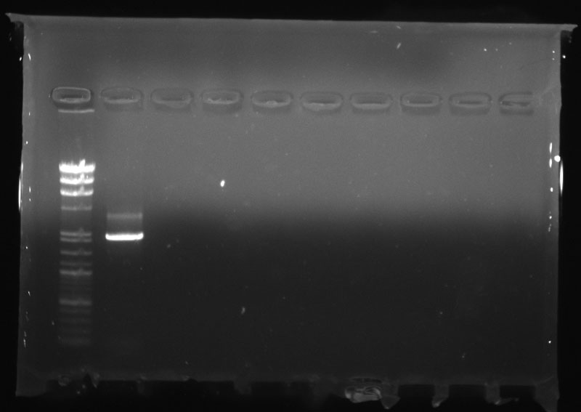
- To make a standard 1% gel use 75 ml of 1XTAE and 0.75 grams of agarose (regular agarose, not low melt). Put it into the microwave for about 90 seconds or until the agarose is completely dissolved. Pulsing the microwave may be necessary to prevent boiling over.
- Add 12 ul of 1 mg/ml ethidium bromide and swirl to mix. BE sure TO wear gloves AND to handle ethidium bromide carefully, it is a carcinogen.
- Allow the flask to cool so that the glass feels warm/hot, not burn/hot. Pour the liquid onto the gel bed and let it cool. Insert the appropriate sample comb.
- Add loading dye to each PCR product. This will enable you to visualize sample progress through the gel as well as aid in keeping the sample in the wells (the dye contains glycerol). Do this by adding 6 uL of the 10X loading dye to a 50-ul PCR.
- Move the gel into the proper orientation in the gel box, cover your gel with 1X TAE buffer and load all your products into the (4-5 uL per well should be sufficient). DON’T FORGET TO ADD A DNA LADDER AS A REFERENCE. Put the lid on and make sure that the negative and positive electrodes are in the correct places (red to red, black to black). DNA is negatively charged so the DNA will run toward the positive, red electrode. Turn on the power supply and run at 150-175 volts. It will take about 15-30 minutes to complete depending on the desired resolution.
- Visualize the gel on the Alphaimager. Print off the results and log in your notebook.

Preparation of chemically competent DH5α

(Rubidium chloride protocol)

It is easiest to make a whole bunch of competent cells at once. They may be stability kept at -80˚C .

Day 1
Streak DH5α for isolation on LB plate (no ampicillin).
Grow at 37 ˚C.

Day 2
- At the end of the day, add a single colony to a 4-16 ml (4 ml for 1X, 16 ml for 4X) SOB media aliquot for overnight culture at 37 ˚C and 250 rpm.

Day 3

- Add 4.0 mls overnight culture to 400 ml SOB in 2L flask. Grow at 37 ˚C and 250 rpm until OD₅₅₀ = 0.4-05 (2-3 hours). Transfer to conical 250 ml Tubes.
- Chill 5-10 min on ice. From here on, all steps must occur in a cold environment, including centrifugation steps.
- Spin at 3-4k for 10 min. Pour off sup.
- Resuspend cell pellet by pipetting in 150 ml TFB I. Ice for 5 min
- Spin at 3-4k for 10 min at 4 ˚C. Pour off sup.
- Gently resuspend in 15 ml TFB II (if > 1X pool together, e.g. 60 ml for 4X). Ice for 15 min
- Aliquot 50 ul to prechilled (at -80°C), sterile 0.5 ml microcentrifuge tubes. Snap freeze in matrix of dry ice crushed to powder and store in -80°C . FLASH FREEZING AND REMAINING FROZEN ARE THE KEYS TO HIGH COMPETENCY RATES. WHEN DOING LARGE BATCHES OBTAIN EPPENDORFS FROM FREEZER IN BATCHES, IMMEDIATELY BEFORE USE. Bacteria are ready for transformation.

SOB Media
Reagent/Final Vol | 400 ml | 800 ml | 1600 ml
Tryptone | 8 g | 16 g | 32 g
Yeast | 2 g | 4 g | 8 g
NaCl | 0.2 g | 0.4 g | 0.8 g
0.25 M KCl (add after dissolving the foregoing) | 4 ml | 8 ml | 16 ml
pH 7.0 with 5 N NaOH. Autoclave. Add 2 mls filter sterilized 2M MgCl₂ to each 400 ml.

TFB I
Reagent final concentrations | F.W. | 200 ml | 400 ml | 800
30 mM Potassium acetate | 98.14 | 0.59 g | 1.18 g | 2.36 g
100 mM RbCl | 120.9 | 2.42 g | 4.84 g | 9.68 g
10 mM CaCl₂ | 147 | 0.294 g | 0.59 g | 1.18 g
50 mM MnCl₂ | 197.9 | 1.98 g | 3.96 g | 7.92 g
15% Glycerol | N/A | 30 mls of 100% | 60 ml of 100% | 120 ml of 100%
pH 5.8 w/ Acetic Acid (do not overshoot—correcting with KOH will cause irreversible precipitation). Filter sterilize.

TFB II
Reagent final concentrations | F.W. | 100 ml
10 mM MOPS | 209.3 | 0.209
75 mM CaCl₂ | 147 | 1.102
10 mM RbCl | 120.9 | 0.121
15% Glycerol | N/A | 15 ml
pH 6.5 w/ KOH. Filter sterilize.

0.25 M KCl (F.W. = 74.55)
1.86 g KCl/100 ml H₂O. Filter sterilize.

2M MgCl2 (Hexahydrate = F.W. 203.3)
40.66 g MgCl₂ to 100 ml. Filter sterilize.

