Select and Hire Candidate (Non-Student)
How to Hire a Candidate after Creating a Job Requisition
- On the homepage for Workday, select the Recruiting icon.
- On the top left column click the My Candidates button.

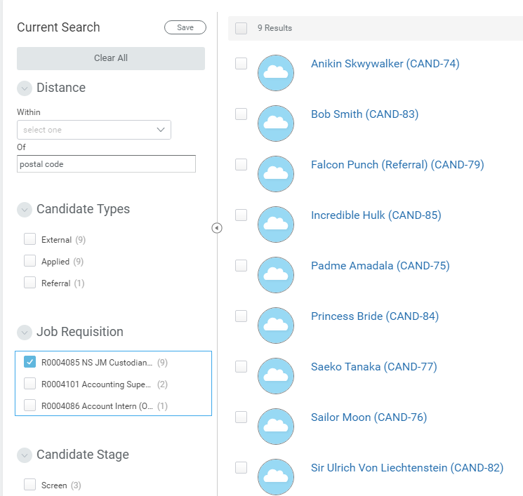

Use the Job Requisition filter box to sort Candidates to include applicants for that particular job opening.

(2nd Option) You also have the alternative to select job requisitions that were recently posted. These will be located on the bottom of your page after selecting the Recruiting icon. After selecting your posted requisition from the Recent list like the one pictured below, select the Candidates tab to display a listing of all applicants who applied for that job.

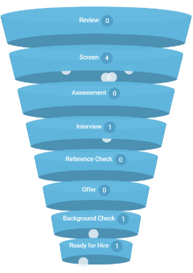

Many tools are provided to help compare each candidate with one another.

- Click on a candidate to view their applicant information.
- Use the different tabs to comb through their application. The Attachments tab is where any uploads the applicant provided, like a résumé, will be found.

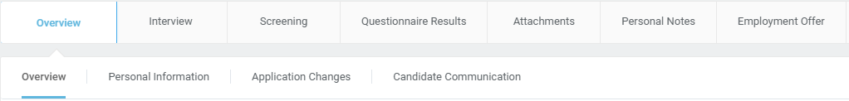

- At the bottom of the page there are a few options; here you will decide whether this candidate will Move Forward in the process (Interview), or whether to choose Decline.
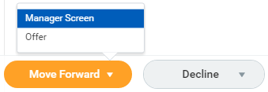

- This option will also be available in your Inbox.

- After selecting the Interview button for all the candidates you are considering, it is time to schedule these interviews with their these candidates, their email address, phone number and contact information will all be listed under their candidate profile.
- As a manager it is ultimately your decision on whom you hire. We recommend that you select a committee for interviewing and work with oumployment office as you decide who should be on that committee.
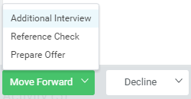
- Once you have made your selection, move the candidate forward to Send to Offer this will get the compensation piece moving.

- This candidate will have to be assigned a pay rate and be verified through HR Employment. Once this process is complete, another message will appear in your Inbox. You will now be able to notify the candidate that they are being offered the opening. If everyone is still on board, in that message there will be another option to Move Forward. This time you will select Background Check.
- All that is left now is to wait on HR to check background, ecclesiastical endorsements, etc. Once they are good to go, their onboarding process will commence.

