Western Blotting Protocol
QUICK REFERENCE
- Run SDS-PAGE and transfer at least 4 hours to nitrocellulose membrane or PVDF membrane.
- Block 1 hour in 5% milk TBST, rinse blot once with TBST.
- Incubate overnight at 4’C in 1% milk TBST 1:1000 primary antibody (dilution is completely dependent upon antibody being used, can very from 1:250 to 1:5000). Antibody should be reused for months.
- Wash blot 3 times with TBST for 10 minutes each
- Soak blot in secondary antibody (1:3000 in 1% milk TBST) for 2 hours.
- Wash blot 3 times in TBST for 10 minutes each, then a final wash in TBS and develop.

I. Materials
- Transfer buffer: 4L = 57.64g glycine; 12.12g Tris base; 800ml Methanol; ddH₂O to 4 liters. Store at 4°C.
Recycle 5 times
- TBS (1x): (20 mM Tris, 500 mM NaCl)
2L = 4.84g Tris; 58.48g NaCl; ddH₂O to 2 liters adjust pH to 7.5 with conc. HCl.
- TTBS: 1L = 0.5ml of Tween-20 to 1 liter of TBS
- Blocking buffer: 50ml of TBS with 5% dry milk
- Antibody buffer: make up 10ml – antibodies are expensive so use as little as possible. Antibody solutions can be saved in the fridge for ~1 month and reused.
  - Primary: use as per manufacturers instructions. This is usually a 1:500 dilution in 1x TBST with 1% BSA.
  - Secondary: Use either anti-rabbit or anti-mouse depending on primary antibody. Secondary antibodies are usually used at a 1:10,000 dilution in TBST with 1% dry milk.
  - HRP color development solution: Mix together equal amounts of the reagents right before use. DO NOT MIX EITHER REAGENT INTO THE STOCK VIALS!
  - Stripping Buffer: 67.5mM Tris. Cl pH 6.7; 2% SDS; 100mM β-ME
II Method
- Prepare samples for gel. See preparation of yeast cells for western blotting if necessary. Prepare protein MW markers for gel by boiling the desired amount to be loaded in gel.
- Pour a SDS-PAGE gel.
- Western Blot: With gloves, carefully measure and cut nitrocellulose rectangles the size of the western blot sponges. Pour transfer buffer into a large Tupperware tray. Slip one rectangle of nitrocellulose in at a 45° angle. Leave for a few minutes.
- Open up glass plates of SDS-PAGE gel. Remove stacking gel by scraping off. Carefully bind a rectangle of 3mm paper on top. Roll out air bubbles gently with a plastic pipette. Wet sponges in transfer buffer and put one under and one over the sandwich. Roll out the air bubbles gently. Place sandwich in plastic “cage” with black side on gel side.
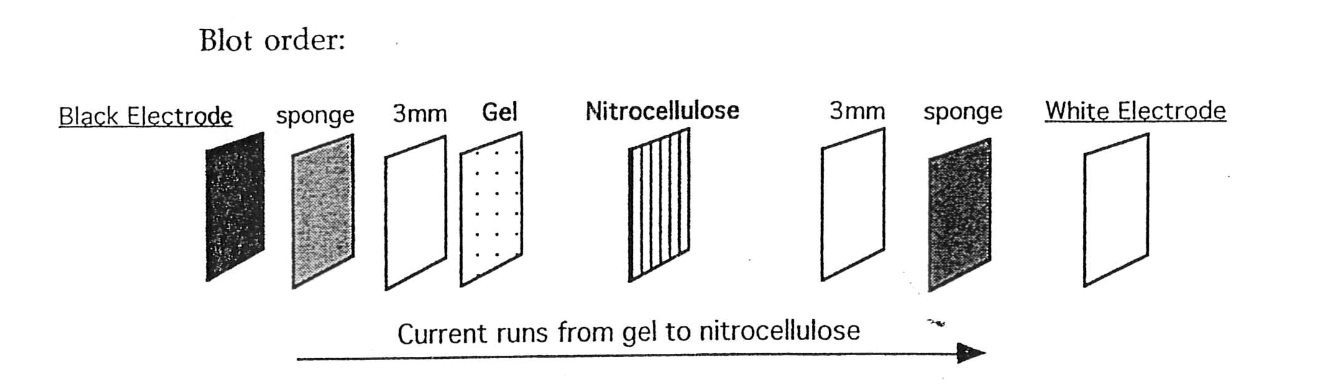
- Set up Western blot apparatus with stir bar inside and ~1/2 full of transfer buffer. Put ice block (or water cooler for large transfer) and sandwich cage(s) inside electrode box. When it’s all set up, the transfer buffer should be at the top of the chamber. Place on stir plate and stir rapidly. Set amperage at < 500 mA. As the temperature increases, amperage will increase and the power supply will buzz if it goes over 500mA. Transfer for 1.5 hours. (If using the 200/2.0 power supply, run mini-blot at 300V or full size blot at 800mA.) Be careful – high amperage kills!
- Open up sandwich and check that all visible markers have transferred to the nitrocellulose.
- Wearing gloves put nitrocellulose in 50 ml blocking buffer and shake for 1 hour. Pour out blocking buffer. Rinse blot once with TTBS.
- Put nitrocellulose into 1° Ab buffer. Incubate with shaking for 2 hours -> overnight.
- Wash blot 3 times with TTBS for 10 minutes each.
- Soak blot in 10mls of Antibody buffer + 2°Ab. Incubate 1 hour.
11. Wash blot 3 times in TTBS for 10 minutes each. Then wash once in TBS. Pour off TBS and add color development solution made immediately prior to using. Quickly blot off nitrocellulose paper (NP) on paper towel. Then incubate NP in reaction mix for 1-2 min (up to 10 if you suspect a low signal). Then blot off and wrap in syran wrap, tape into cassette. Expose on film. There should be bands forming within 1 minute. Once bands are clearly visible, rinse blot with water, dry and photograph, if desired. ffffffffffffffffffffffffffffffffffffffffffffffffffffffffffffffffffffffffffffffffffffffffffffffffffffffff
- If you need to strip and reprobe use ~20-30ml Stripping buffer. Incubate at 50° for 30 minutes. Rinse, blot well, and reprobe.

